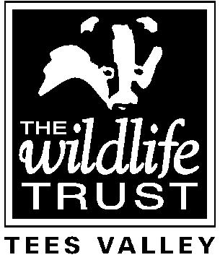TEES VALLEY WILDLIFE TRUST - APPLICATION FOR EMPLOYMENT

Post applied for:

Forenames:

Surname:
Email address
Present Address:
Permanent Address (if different)
Telephone No.
National Insurance Number
Where did you see the post advertised?

EDUCATION (From Secondary level, in date order)
Dates | Establishment | Qualifications

TRAINING
Training Courses Attended | Date | Skill/Qualification Obtained

Please give details of any membership of professional or other organisations

CURRENT EMPLOYMENT
Current job title
Name and address of current employer:
Date of appointment:
Please outline your duties:

PREVIOUS EMPLOYMENT (in date order, starting with the most recent.)
Dates | Employer, including address | Job Title

Please give details of any gaps in your employment history

SUPPORT FOR YOUR APPLICATION
Please describe how your past experience makes you suitable for the post.

OTHER INTERESTS
Please describe any interests or hobbies that may be relevant to your application.

Do you hold a full driving licence?
Does your licence include entitlement to drive a mini-bus?

REFERENCES
We require details of two referees
Name:

Address:

Daytime telephone no.:
Relation to you:
Can we contact this referee without contacting you first?
Name:

Address:

Daytime telephone no.:
Relation to you:
Can we contact this referee without contacting you first?

DECLARATION
By signing this declaration you are agreeing with the statements below, which may be referred to in the future.
- I confirm that all the details I have provided in this application form are correct, and that I have not deliberately withheld any relevant information;
- I have not attempted to influence an employee of Tees Valley Wildlife Trust in connection with this application;
- I understand that deliberately providing false information, failing to disclose relevant information or attempting to influence the recruitment process unfairly may lead to my application being rejected, any offer of employment (whether paid or unpaid) being withdrawn, or actual employment (whether paid or unpaid) being terminated;
- I give consent for Tees Valley Wildlife Trust to be given details of my attendance record over the last two years, including periods of sickness and other absence and the reasons for them, for reference purposes;
- I confirm that I have a right to work in the UK and that I have documentary evidence for this
- I accept that the information provided on this application form may be held, further processed or verified in accordance with the General Data Protection Regulations.

Signed: Date:

Please return your completed application form by email to: info@teeswildlife.org

