Volunteer Role Description

Volunteer Role Title | Role Number
Sea Watch Observer
Reserve, Project, Team or Area
Yorkshire, Durham, Tees Valley and Lincolnshire coastline, Living Seas team
Volunteer Manager
Bex Lynam, North Sea Marine Advocacy Officer
Why do we need you?
Are you passionate about protecting marine wildlife? Do you have a special interest in cetaceans (whales, dolphins, porpoises)? Could you help us to learn more about the regions cetacean populations by regularly carrying out surveys?

Cetaceans are a common sight in UK waters, with regular sightings of minke whales, harbour porpoise, white beaked dolphins and even humpback whales, off the Yorkshire and North East coastline. Despite this, cetaceans face numerous threats from human activities. If we are to protect cetaceans in our waters then more information on their numbers and locations is required. The North Sea Wildlife Trusts (Durham, Tees Valley, Yorkshire and Lincolnshire) and Sea Watch Foundation are teaming up to improve data collection in this area and would like the help of passionate volunteers to become dedicated Sea Watch Observers to help us achieve this.
By becoming a Sea Watch Observer you will provide important information about how, where and when cetaceans use our coastal waters, enabling us to better protect these animals using conservation measures. Anyone can be an Observer: all you need is enthusiasm, a pair of binoculars (provided) and a little patience. If you enjoy spending time by the coast regularly, why not take time to record what you see – and what you don’t?!
We will provide full training on how to undertake dedicated cetacean surveys for all volunteers. Liaising with the project co-ordinator, you will decide on a ‘watching station’ on the coastline from which to regularly conduct surveys.
Although any information on cetaceans is useful to us, it is essential that Observers regularly collect “effort related” data. “Effort-related” data means that observers time their watch and collect environmental data every 15 minutes during the watch. There is no set time for a watch period, as long as time, date and location are carefully noted, along with any sightings information.
About each organisation:
For over a decade the North Sea Wildlife Trusts have worked to conserve our marine wildlife and habitats, with the aim of contributing to achieving The Wildlife Trust’s national vision for our seas. Our vision is for:
- Marine wildlife to recover from past decline as our use of the seas’ resources become environmentally sustainable
- The natural environment to adapt well to a changing climate, and ocean processes help to slow down climate change
- People to be inspired by marine wildlife and value the sea for the many ways in which it supports our quality of life
SeaWatch Foundation (SWF) is a national marine environmental charity working to improve the conservation of whales, dolphins and porpoises in the seas around Britain and Ireland. SWFs aims are to:
- Involve the public in scientific monitoring
- Raise awareness and understanding of marine mammals and the threats they face and
- Educate, inform and advise for better environmental protection

What will you be doing?
The volunteer will contribute information to a national database on cetaceans by conducting land-based sea watch surveys from your local coastline. Tasks the volunteer will undertake include:

- recording cetacean sightings data from a designated ‘watching station’ on the coast
You will use paper data sheets. We will work with each volunteer to agree on a watching location that works for us and the volunteer
- Submitting your survey data to the regional co-ordinator on a regular basis
- Reporting your sightings, particularly unusual ones, to the regional co-ordinator as soon as possible (various platforms available including phone, email and dedicated Facebook group)
- helping with outreach events (optional)
You will have the option to help with outreach efforts and/or run your own public sea watching events e.g. during Puffin Festival, National Whale and Dolphin Watch week, conferences, community events, volunteer fairs, etc.
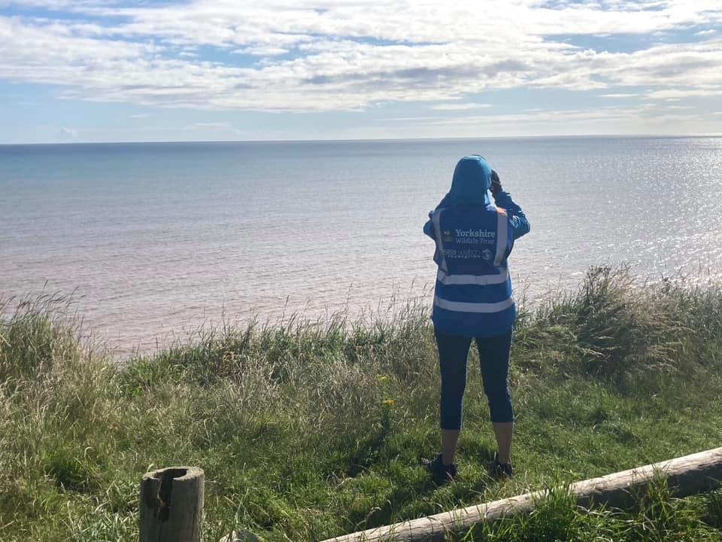
Photo Credit: Steven Arscott

Experience, knowledge and skills needed for this role
Volunteer Skills/Qualities
Required:
- Passion for conservation of the marine environment
- An interest and knowledge of British cetaceans or the enthusiasm to learn
- Attendance at Sea Watch Observer training course is mandatory
- Ability to record sightings information accurately and in detail (recording forms provided)
- Ability to survey outdoors for approximately 1 hour
- Proactive with the ability to work independently and unsupervised
- A mature and responsible attitude
- Flexible and adaptable approach as you may volunteer outside of normal office hours
- An understanding of health and safety and the risks involved with working by the sea

Desirable or willingness to learn:
• Knowledge of the marine environment
- A basic knowledge of cetacean identification
- First aid qualified (if helping with events)
- Close proximity to watching station
- Interpersonal communication skills

Volunteers should be 18 or over, or if 14-18 should be supported and supervised by a responsible adult and have parental/guardian consent to take part.

Does the volunteer need a driver’s licence?
Dependent on sea watching location. Volunteers should be able to easily reach their sea watching station (preferably within walking/cycling distance of your home/place of work)
What’s in it for you?
By joining the network of Sea Watch Observers in this region and across the country, you will be contributing to the national database of information held on cetacean species in UK waters and so have a direct part to play in their conservation. You’ll learn about the cetaceans frequenting the north east coastline and gain experience in field work, plus:

- Relevant training for the role e.g. Risk Assessments, Health and Safety, Observer training
- Become a valuable member of a professional team
- Experience of working within a large conservation organisation
- Opportunity to learn more about cetaceans
- Opportunity to get involved in a national citizen science project
- Access to our internal volunteer training programme
- Dedicated equipment provided
- Opportunity to meet with other Observers in the area

Where is the role based?
Assigned sea watching station (various available along Durham/Yorkshire/Tees Valley/Lincolnshire coastline) which should be close to your home or place of work for ease of access. We will work with you to choose an appropriate station from which to record sightings information

Commitment
There is plenty of flexibility in this role as you can choose when you would like to carry out your sea watches. Ideally you will undertake at least one survey per month but you can complete as many as you wish – the more data we receive the better! As a regular volunteer you will also be invited to attend optional volunteer thank you days throughout the year.

Duration
Ongoing

How to Apply:

Please download and send your completed application forms to your local Wildlife Trusts by the closing deadline 9am Monday 21st February 2022

Yorkshire Wildlife Trust – volunteering@ywt.org.uk

Durham Wildlife Trust – dkealoha@durhamwt.co.uk

Tees Wildlife Trust – education@teeswildlife.org

Lincolnshire Wildlife Trust - dmiller@lincstrust.co.uk

Applications for Yorkshire: Due to the large geographic area of Yorkshire and the popularity of the Sea Watch Observer volunteer role, in the first instance preference will be given to those living within 50 miles of the coast (roughly equivalent to a 1 hour drive)

What training is required to fulfil this role?

Attendance at Sea Watch Observer training course is essential. The next online course will take place on Saturday 12th March 2022 and will be a half day course from approximately 9am until 1pm.

To access this online training you will need:
- Access to a computer, tablet or mobile phone (larger screen preferable so viewing of training imagery is easier to see).
- Reliable internet access
- A modern version of your web browser installed
- Email address

