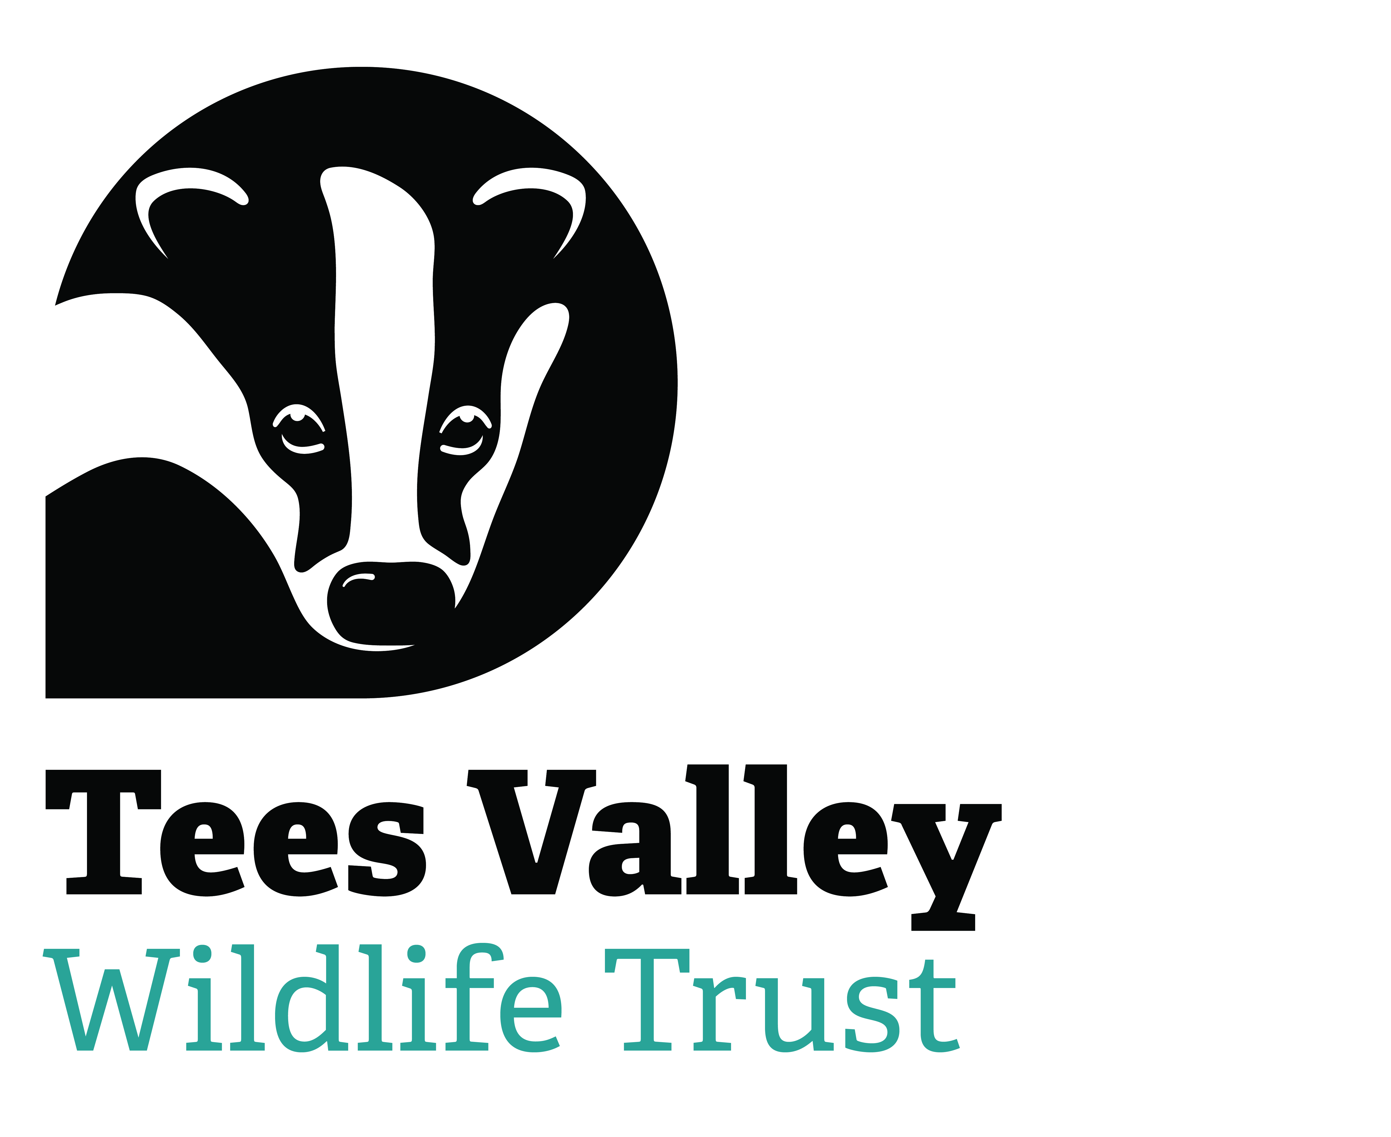

TEES VALLEY WILDLIFE TRUST - APPLICATION FOR EMPLOYMENT

Post applied for:

Forenames:

Surname:
Email address
Present Address:
Permanent Address (if different)
Telephone No.
National Insurance Number
Where did you see the post advertised?

Education and training
Please give details:

Qualifications
Please give details:

Employment history
Your current or most recent employer

Name of employer:

Address:

Postcode:

Job title:

Pay:

Length of time with employer:

Reason for leaving:

Duties:

Previous employers
Please tell us about other jobs you have done and about the skills you used or learned in those jobs.

Please give details of any gaps in your employment history

Supporting statement
Please tell us why you applied for this job and why you think you are the best person for the job.

OTHER INTERESTS
Please describe any interests or hobbies that may be relevant to your application.

Do you hold a full driving licence?
Does your licence include entitlement to drive a mini-bus?

REFERENCES
We require details of two referees
Name:

Address:

Daytime telephone no.:
Relation to you:
Can we contact this referee without contacting you first?
Name:

Address:

Daytime telephone no.:
Relation to you:
Can we contact this referee without contacting you first?

Additional question, only for posts requiring a DBS check because of its work with children or vulnerable adults
Do you have any unspent convictions, cautions, reprimands or warnings? | Yes/No

DECLARATION
By signing this declaration, you are agreeing with the statements below, which may be referred to in the future.
- I confirm that all the details I have provided in this application form are correct, and that I have not deliberately withheld any relevant information;
- I have not attempted to influence an employee of Tees Valley Wildlife Trust in connection with this application.
- I understand that deliberately providing false information, failing to disclose relevant information or attempting to influence the recruitment process unfairly may lead to my application being rejected, any offer of employment (whether paid or unpaid) being withdrawn, or actual employment (whether paid or unpaid) being terminated.
- I give consent for Tees Valley Wildlife Trust to be given details of my attendance record over the last two years, including periods of sickness and other absence and the reasons for them, for reference purposes and for this to be held in accordance with the Data Protection Act 1998.
- I confirm that I have a right to work in the UK and that I have documentary evidence for this.
- I note that the information provided on this application form may be held, further processed, or verified in accordance with the Data Protection Act 1998.

Signed: Date:

Please return your completed application form by email to: info@teeswildlife.org

